The Country Dartball League
would like to Thank
this years sponsors

Arrowhead Golf Course
EJ’s on Bark Lake
Fat Charlie’s (2 teams)
Hairy Lemon
Lone Star Black
Madam Belles Saloon (2 teams)
Pioneer Bowl
Richfield Chalet
Sal’s Pub & Grill
Sheryls Club 175
Sportscorner (2 teams)
Tally Ho (2 teams)
Toms Bar & Grill
Whiskey Corners

Thank You to Tom and the staff at Richfield Chalet for hosting the mid-season team Tournament in January.

Thank You to Jason Pipkorn, Jamie Larkin, Joe Schulteis, and the staff at Madam Belles for hosting this years banquet.

Mike Henes of Plaques Plus in Hubertus is the official supplier of this years trophies, plaques and mugs.

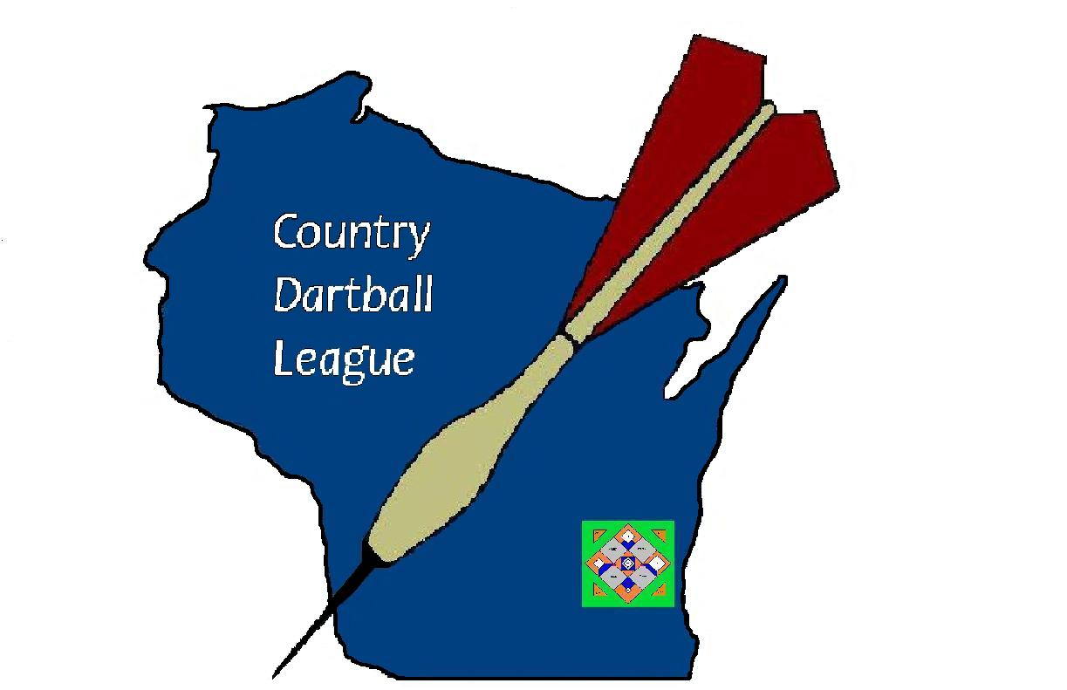
Country Dartball League
2011-2012

Year End awards
League MVP- Marv Mathiak- Richfield Chalet

High Singles
Marv Mathiak- Richfield Chalet (.537)
Gary Kapal- Toms Bar (80 singles)
Kim Schmitt- Richfield Chalet (.533)
High Triples
Marv Mathiak-Richfield Chalet (.537)
Eric Muth- Arrowhead Golf (.494)
Rick Petrowski -Pioneer Bowl (.444)
High RBI
John Hake- Richfield Chalet (78)
Jim Ehnert- Whiskey Corners (66)
High Average
Marv Mathiak- Richfield Chalet (.537)
Mark Lighthizer- Toms Bar (.535)
Mark Ruhbusch-Richfield Chalet (.476)
Eric Muth-Arrowhead Golf (.473)
Todd Halverson-Whiskey Corners (.473)
Gary Kapal-Toms Bar (.471)
Kim Schmitt-Richfield Chalet (.459)
Mike Aulenbacher- Arrowhead Golf (.454)
George Hanson-Richfield Chalet (.447)
Frank Wiedmeyer- Lone star Black (.437)
Rick Petrowski-Pioneer Bowl (.435)
Gary Wolf-Sportscorner III (.433)
Andy Okrasinski-Richfield Chalet (.429)
Perry Montini- Whiskey Corners (.427)
John Hake-Richfield Chalet (.424)
Mark Gettelman-Richfield Chalet (.423)
Bill Brockman- Sportscorner I (.420)
Mike Kuepper- Toms Bar (.418)
Scott Zandi-Sportscorner III (.417)
Mike Metzger-Pioneer Bowl (.415)
Wally Wolf- Sportscorner III (.415)
Jim Wolin-Whiskey Corners (.406)
Dan Lighthizer- Toms Bar (.404)
Lavern Schuster- Pioneer Bowl (.402)
Pete Fritz- Lone Star Black (.401)
Woody- Pioneer Bowl (.401)
Kenneth Roskopf-Sportscorner III (.400)

Rookie-of-the-year
Nick Froemming- Sportscorner I (.358)

www.countrydartball.com

The first full year of countrydartball.com was a huge success. Thank You to Derek Schwechel, Captain of
Fat Charlies II, for acting as League Webmaster.
Derek was responsible for web-page design, statisticical input, and posting league updates and information.

Thank You Derek, the site is awesome.

Our league information is also now listed on www.widartball.com.

Looking forward to
2012-2013…

Next season will offer expanded playoffs and payouts, including:

- A Consolation bracket for non-playoff teams
- A 3rd place game with payouts for playoff round
- Payouts for 2nd place team in playoff round.
- Expanded individual awards

State Dartball
The Country Dartball League and Richfield Chalet will be hosting the 2012 State 4-man Championship on December 1, 2012.
Sign up early, field is limited to 32 teams.

Playoffs |  |  |  |  | G3
  PLAYOFFS ROUND 1 | G1 |  | G2 |  | G3
  SHERYLS | 5 |  | 6 |  | 2
  RICHFIELD CHALET | 4 |  | 17 |  | 17
  ARROWHEAD GOLF | 4 |  | 10 |  | 8
  WHISKEY CORNERS | 5 |  | 7 |  | 9
  SPORTSCORNER 3 | 5 |  | 4 |  | 8
  PIONEER BOWL | 3 |  | 14 |  | 2
  SPORTSCORNER 1 | 2 |  | 10 |  | 13
  TOMS BAR | 7 |  | 4 |  | 10
  PLAYOFFS ROUND 2 | G1 |  | G2 |  | G3
  WHISKEY CORNERS | 9 |  | 3
  RICHFIELD CHALET | 10 |  | 5
  SPORTSCORNER 1 | 6 |  | 1
  SPORTSCORNER 3 | 10 |  | 13
  CHAMPIONSHIP | G1 |  | G2 |  | G3
  SPORTSCORNER III | 5 |  | 10
  RICHFIELD CHALET | 10 |  | 15

Mid-Season tournament
Champion- Richfield Chalet
Runner up- Toms bar
Tournament MVP- Kim Schmitt- Richfield Chalet

December 4-man Tournament
Champion- Whiskey Corners

Season Standings
FINAL
SH DIVISION | W | L | % | GB
TOMS BAR-x | 41 | 10 | 0.804 | --
WHISKEY CORNERS-y | 36 | 15 | 0.706 | 5
MADAM BELLES I | 29 | 22 | 0.569 | 12
TALLY HO II | 23 | 28 | 0.451 | 18
FAT CHARLIES I | 20 | 31 | 0.392 | 21
SALS PUB & GRILL | 12 | 39 | 0.235 | 29
2BS DIVISION | W | L | % | GB
RICHFIELD CHALET-x | 46 | 5 | 0.902 | --
SPORTSCORNER III-y | 30 | 21 | 0.588 | 16
SHERYLS-y | 29 | 22 | 0.569 | 17
LONE STAR BLACK | 25 | 26 | 0.490 | 21
HAIRY LEMON | 18 | 33 | 0.353 | 28
TALLY HO I | 7 | 44 | 0.137 | 39
DP DIVISION | W | L | % | GB
PIONEER BOWL-x | 38 | 13 | 0.745 | --
ARROWHEAD GOLF-y | 32 | 19 | 0.627 | 6
SPORTSCORNER I-y | 30 | 21 | 0.588 | 8
FAT CHARLIES II | 20 | 31 | 0.392 | 18
MADAM BELLES II | 17 | 34 | 0.333 | 21
EJ'S | 6 | 45 | 0.118 | 32
x-division champion y- playoff qualifier

Team Stats
ARROWHEAD GOLF 32-19 (2ND PLACE DIVISION)
6.8 RUNS/GAME HOME (14-13) AWAY 18-6
TOP HITTERS- E. MUTH (.473) E. MUTH (50 RBI)
EJ'S ON BARK LAKE 6-45 (6TH PLACE DIVISION)
1.4 RUNS/GAME HOME (4-20) AWAY (2-25)
TOP HITTERS JARROD AND JASON
FAT CHARLIES I 20-31 (5TH PLACE DIVISION)
3.8 RUNS/GAME HOME (9-15) AWAY (11-16)
TOP HITTERS
FAT CHARLIES II 20-31 ( 4TH PLACE DIVISON)
4.8 RUNS/GAME HOME ( 12-15) AWAY (8-16)
TOP HITTERS
HAIRY LEMON 18-33 (5TH PLACE DIVISION)
3.3 RUNS/GAME HOME (5-19) AWAY (13-14)
TOP HITTERS
LONE STAR BLACK 25-26 (4TH PLACE DIVISION)
4.7 RUNS/GAME HOME (12-15) AWAY (13-11)
TOP HITTERS F. WIEDMEYER (.437) P. FRITZ (49 RBI)
MADAM BELLES 1 29-22 (3RD PLACE DIVISION)
5.2 RUNS/GAME HOME (13-11) AWAY (16-11
TOP HITTERS W. HANDLELAND (.394) R. MOLL (38 RBI)
MADAM BELLES II 17-34 ( 5TH IN DIVISION)
2.73 RUNS/GAME HOME (5-19) AWAY 12-15)
PIONEER BOWL 38-13 (DIVISION CHAMPION)
7.6 RUNS/GAME HOME (15-9) AWAY (23-4)
TOP HITTERS R. PETROWSKI (.435) S. CONTO (56 RBI)

Team Stats
RICHFIELD CHALET 46-5 DIVISION CHAMPION
10.6 RUNS/GAME HOME (24-3) AWAY (23-1)
TOP HITTERS M. MATHIAK (.537) J. HAKE (78 RBI)
SALS PUB & GRILLE 12-39 (6TH PLACE DIVISION)
2.3 RUNS/GAME HOME (4-20) AWAY (8-19)
TOP HITTERS MIKE (.316) CHRIS (18 RBI)
SHERYLS CLUB 175 26-22 (3RD PLACE DIVISION)
5.7 RUNS/GAME HOME (13-14) AWAY (16-8)
TOP HITTERS
SPORTSCORNER I 30-21 (3RD PLACE DIVISION)
5.9 RUNS/GAME HOME (15-9) AWAY (15-12)
TOP HITTERS B. BROCKMANN (.420) E. SCHAEFER (43 RBI)
SPORTSCORNER III 30-21 ( 2ND PLACE DIVISION)
6.6 RUNS/GAME HOME (16-11) AWAY (14-10)
TOP HITTERS G. WOLF (.433) S. ZANDI (54 RBI)
TALLY HO I 7-44 (6TH PLACE DIVISION)
1.3 RUNS/GAME HOME (5-19) AWAY (2-25)
TOP HITTERS
TALLY HO II 23-28 (4TH PLACE DIVISION)
4.2 RUNS/GAME HOME (17-10) AWAY (6-18)
TOMS BAR & GRILLE 41-10 (1ST PLACE DIVISION)
9.2 RUNS/GAME HOME (20-7) AWAY (21-3)
TOP HITTERS M. LIGHTHIZER (.535) M. LIGHTHIZER (56 RBI)
WHISKEY CORNERS 36-15 (2ND PLACE DIVISION)
7.3 RUNS/GAME HOME (18-9) AWAY (18-6)
TOP HITTERS T. HALVERSON (.472) J. EHNERT (66 RBI)

